Fighting Childhood Obesity at Eisenhower Elementary School

James J. Kim

Childhood obesity is a nationwide epidemic that affects millions of children throughout our country. One of the root-cause of childhood obesity is public school lunch program, and it is currently impacting the well-being of the students at Eisenhower Elementary School. There have been numerous studies conducted by Centers for Disease Control to gain a better understanding of this issue, and Congress has attempted to solve this epidemic by introducing several fundamental changes to the lunch program. Despite the efforts, the current solutions have not made any significant impact, and students are still affected each day. In 2010, the Journal of School Health stated students at public schools who participate in the National Public Lunch Program have a 4.5 percent probability of being overweight. Furthermore, children have higher BMI than those attending private school. Disease Control and Prevention reported that 17 to 30 percent of children ages 2 to 19 are overweight or obese (Cooper, 2016). Reducing the amount sugar intake and eliminating excess calories can drastically help to prevent childhood obesity. In an effort to improve the health and prevent further obesity at Eisenhower Elementary, there is an imperative need to improve the current lunch menu, and your support can help to make a significant impact. It is critical to take an immediate action to remove flavored milk from the lunch menu and provide our children with a healthier alternative.

Any attempt to solve childhood obesity is a monumental undertaking, and we're undoubtedly not trying to resolve this issue here. However, what we are attempting is to make a small change that will have a lasting impact on the health of our children. A program like Healthy Hunger-Free Kids Act strives to provide healthy and balanced meals, thus providing healthier options for students. The daily lunch program incorporates whole grain meals, fruits, and choice of beverages. Under the initiative, students have an option of choosing a fat-free or 1 percent flavored milk (U.S. News 2016). However; it fails to recognize the high sugar content in flavored milk, which can contain up to 50 grams of sugar. To put this number into perspective, a single can of Coca-Cola contains 39 grams of sugar. If students were to consume all the available meals at school, they would be drinking close to 100 grams of excess sugar per day.

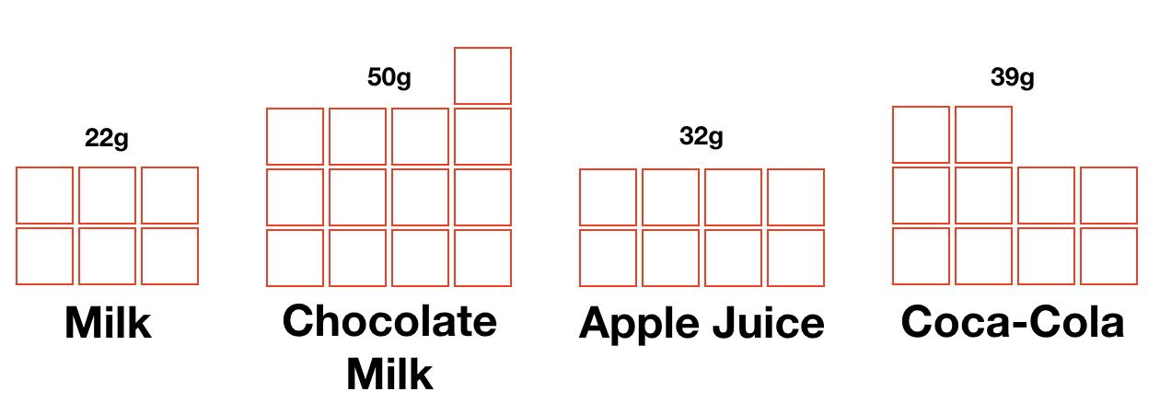

Switching from one sugary drink to another is not a solution. The most logical way to approach this issue is by eliminating the flavored milk entirely from the menu. Although this may seem like a drastic measure, it is the most feasible way to handle this problem until a permanent solution can be put in place.

Change is possible. In a district in Georgia, concerned parents and PTA petitioned to overhaul their lunch program to provide healthier meals for their students. The new program introduced whole-grain foods and fresh fruits as an alternative, which increased fruit and veggie consumption by 40%. Additionally, sugary beverages were replaced by water and 100 percent juice drinks in all the vending machines (Sifferlan, 2012). Although this may not have eliminated all the sugary beverages from the school campus, it did decrease the number of sugar students was exposed to on a daily basis.

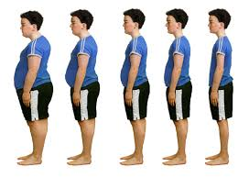

Figure 1: Nutrition for Health (2015) Licensed Under http://www.newjersey-nutrition.com/childhood-obesity.html

Some may argue that we should let the government manage the lunch programs, but the reality is that we continue to face the same issue. The current national lunch program is designed to provide healthy and balanced meals for our kids at school, but it is politicized and lacks the necessary restrictions to protect the kids. The meal guideline recommends availability of different types of milk to school, but according to U.S. News, "powerful dairy lobby to mandate higher consumption of milk in schools and to promote flavored milk as a way to do so, which of course would add more sugar into school meals. (Author, 2016)”

Childhood obesity is on the rise, and it is critical that we take an immediate action to address this problem at our school. It is time to step in and make the right decision that will help shape the lives of all our students. All significant changes have a starting point. The removal of sugar-packed beverages from our lunch menu will not only provide immediate improvement in the health of our students but will be the start of a new beginning to a healthier lifestyle.

References

Auge Karen (2009) The Denver Post [Photograph]  
<http://www.denverpost.com/2009/11/29/colorado-schools-face-cartons-of-controversy-over-milk/>

Cooper Ann (2016) U.S. News  
<https://health.usnews.com/health-news/blogs/eat-run/articles/2016-03-25/snack-crack-our-childrens-addiction-to-sugar>

Julie Kelly, Jeff Stier (2015) *The School Lunch Program With an Unappetizing Report Card* <https://search-proquest-com.ezproxy1.lib.asu.edu/docview/1689552371?accountid=4485&rfr_id=info:xri%2Fsid:primo>

Keith-Thomas Ayoob. Childhood Obesity. August 2011, 7(4): 271-273.   
<https://doi-org.ezproxy1.lib.asu.edu/10.1089/chi.2011.0400.edit>

Li Ji, Ph.D., Hooker Neil H, Ph.D. (2010) Childhood Obesity and Schools: Evidence From the National Survey of Children's Health  
<http://onlinelibrary.wiley.com.ezproxy1.lib.asu.edu/doi/10.1111/j.1746-1561.2009.00471.x/full>

Robinson Thomas N., MD, MPH ( 2005) Preventing childhood obesity: A solution-oriented research paradigm  
<http://www.sciencedirect.com.ezproxy1.lib.asu.edu/science/article/pii/S0749379704003101>

Sifferlan Alexandra (2012) Time   
<http://healthland.time.com/2012/12/31/more-food-for-hungry-students-usda-tweaks-school-meals/>